Charter Revision Committee

Meeting Agenda

November 2, 2022

The following meeting has been scheduled for Wednesday, November 2, 2022:

7:00 pm City Charter Revision Committee in the 2nd floor conference room

Meeting Agenda:
          - Welcome
          - Lou DalPorto
          - Approval of minutes from 10/19 meeting
          - Discussion of items suggested by Mayor Tylec
          - Discussion of spreadsheet from Kate Wistner
          - Sub-committees
          - Next steps

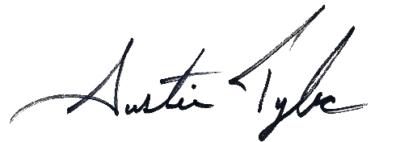
Respectfully submitted,

Austin Tylec
Mayor

